19th September 2008
Title: Determination of density of a liquid using a loaded test-tube.

Aim: To determine the density of a liquid using a loaded test-tube.
Apparatus: A wide test-tube fitted with a mm scale (e.g. by inserting a strip of mm graph paper, marked at cm intervals from the bottom inside it), a deep beaker, some sand, set of weights, vernier calipers, a liquid (water).

Diagram:

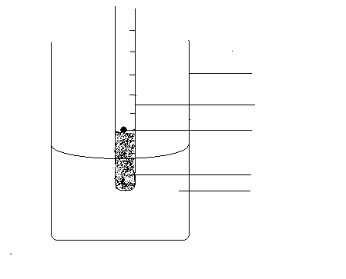
beaker
test tube
mass
sand
liquid

Theory
If the radius of the test-tube is r cm and the mean depth of immersion in cm per g is n (where n is the slope of the depth of immersion against additional load). Then the volume of liquid displaced by the addition of 1gramme to the test-tube =Πr² n cm^{3.}
If the density of the liquid is p gcm⁻³ , then the weight of the liquid displaced =Πr^{2 n} cm^{3.} Hence by Archimedes’ principle: Πr2 n
p=1.Then the density of the liquid p=1/Πr² n gm cm

Method: Sufficient lead shot is placed in the tube to make it float vertically in the liquid and the level (x0) at which it floats is noted. A graph is then drawn of depth of immersion (d) =(x-x0) against additional load. The external radius test-tube is found by using calipers taking four readings. Now cause the test-tube to execute vertical oscillations. Find the periodical time T find the value of g acceleration due to gravity.

^{Table of results:}
^{Xo=11.0 cm}
Least count of vernier calipers: 0.01cm
^{1st reading : 2.54 cm}
^{2nd reading: 2.54cm}
^{3rd reading: 2.53 cm}
^{4th reading 2.55 cm}

m/g | x/cm | d=x-x_{o} | t_{1 /}s | t_{2 /} s | t_{3/} s | t_{4 /} s | t/s | T=t/10
1.0 | 11.2 | 0.2 | 5.56 | 5.59 | 5.66 | 5.66 | 5.62 | 0.56
2.0 | 11.4 | 0.4 | 5.94 | 5.97 | 6.22 | 6.22 | 6.09 | 0.61
3.0 | 11.6 | 0.6 | 6.24 | 6.50 | 6.53 | 6.56 | 6.46 | 0.65
4.0 | 11.8 | 0.8 | 6.63 | 6.78 | 6.81 | 6.85 | 6.77 | 0.68
5.0 | 12.0 | 1.0 | 6.88 | 6.97 | 7.00 | 7.09 | 6.99 | 0.70

Average reading of the test-tube= (2.54+2.54+2.53+2.55)/4=2.54cm

^{Graph:}
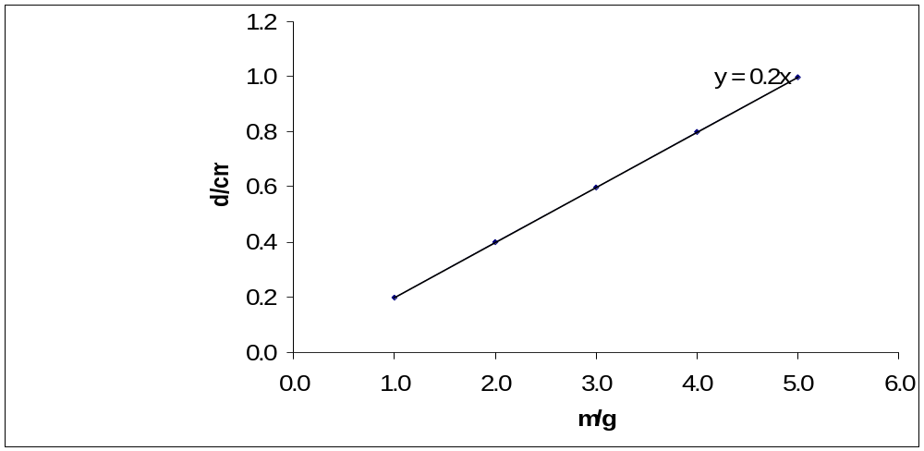

Fig.1 A graph of depth in cm against mass in g.

Calculations:
From the theory,
P=1/Пr² n
Slope (n) =0.2cm/g
(n) =1/0.2g/cm
(n) =5g/cm
r = 2.54cm
P= 1/П(0.254)² (5)
P= 1/1.O1П
P=0.98g/cm3
From the table of results, when x=12.0 cm, T= 0.70s
Using the relation T= 2П√ (l /g); where l=x
g= 4П² l /T²
g= (4П²)(0.12)m/(0.70)² s²
g= 4.74 m/ 0.49s²
g= 9.67m/ s²

Discussion: This experiment was performed to determine the density of water that is 1g/cm³. The slope of the graph of depth in cm against additional mass in g was calculated and substituted in the equation in the theory to find the density of the liquid. The density of the liquid was found to be 0.98g/cm³. The actual value was not achieved due to errors that affected the vertical oscillations and inaccurate readings of the vernier caliper.

Sources of error:
- Error due to wind that affected the vertical oscillations.
- Error due to inaccurate readings taken from the vernier caliper.

Precautions:

- I ensured that the test-tube did not touch the side of the beaker by placing it co-axially with the transparent vessel.
- I took readings of x in level with the meniscus of the water in the beaker.

Conclusion: From the experiment, the density of the liquid that is, water was 0.98g/cm³ .

